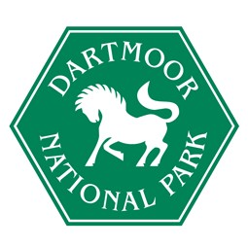

INDEPENDENT PERSON SPECIFICATION

 | Essential | Desirable
Qualifications:
- No specific qualifications or background is required
Knowledge and Skills
- Good listening and questioning skills
- Inquisitive, open-minded, and non-judgemental
- Capable of being assertive
- Able to communicate clearly and effectively in English, both verbally and in writing
- Able to use email and basic digital technology to communicate effectively and access information
- An understanding of the work of Dartmoor National Park Authority
Experience:
- Experience of report-writing
- Experience of working on a committee, working group, steering group, or similar collective body
- Involvement in a regulatory area of activity
- Dealing with complaints, probity, or ethical issues
- Weighing evidence and assessing against criteria
Competencies:
- Trustworthy and dependable
- A person in whose impartiality and integrity the public can have confidence
- Able to build good working relationships with Officers and Members
Other Requirements:
- Able to attend a programme of meetings at Parke (normally six Fridays per annum) and commit preparation time for each meeting
- Willing to attend ad hoc meetings if required
- Must not be disqualified from standing for election as a councillor * (i.e., been adjudged bankrupt or been sentenced to a term of imprisonment for a period of not less than three months in the past five years.)
- Must not be actively engaged in party political activity
- Has not been a member or officer of the Authority or a parish council within Dartmoor National Park in the previous 5 years
- Must not be related to, or a close friend of, any Member or Officer of the Authority
- Willing to enter a formal written undertaking to observe the DNPA Code of Conduct for Members
- Willing to make a Declaration of Financial and Other Interests to be recorded on a public register as required by the Code of Conduct.

