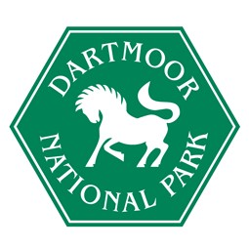

Standards Sub-Committee - Independent Membership

Independent Person

Dartmoor National Park Authority’s Standards Sub-Committee promotes and monitors high standards of conduct for Members and Officers.

It has a key role in advising the Authority on the implementation of the Code of Conduct and assisting Members in observing the Code.

To ensure the integrity of this work a proportion of the Standards Committee must be independent. An Independent Person is someone who at the time of appointment has not been a Member or Officer of the Authority or a parish council within Dartmoor National Park in the previous 5 years and is not a relative or close friend of a member or officer of the Authority.

The Government has stated that it is important that independent persons are seen to be ‘genuinely’ independent of the Authority.

Dartmoor National Park Authority is seeking to recruit an Independent Person to be appointed from November 2026 for an initial three-year period.

The time of commitment may vary, but it is likely to require attendance at Parke, Bovey Tracey for a minimum of six Friday meetings each year.

The appointment is unpaid although an attendance allowance (currently £245.85 per annum) and travel expenses may be claimed.

For further details and/or advice on making an application please contact:

Neil White, Head of Organisational Development and Monitoring Officer
Dartmoor National Park Authority
Parke
Bovey Tracey
Newton Abbot
Devon, TQ13 9JQ
Telephone: 01626 831078
Email: nwhite@dartmoor.gov.uk

Closing date: Friday 9 October 2026 at 12 noon
Interviews: Thursday 29 October 2026

